Project Design Phase-II Technology Stack (Architecture & Stack)

|  |  |
| --- | --- |
| Date | February 2024 |
| Team ID | Team-591930 |
| Project Name | Predicting Mental Health Illness Of Working Professionals Using Machine Learning |
| Maximum Marks | 4 Marks |

Technical Architecture:

The Deliverable shall include the architectural diagram as below and the information as per the table1 & table 2

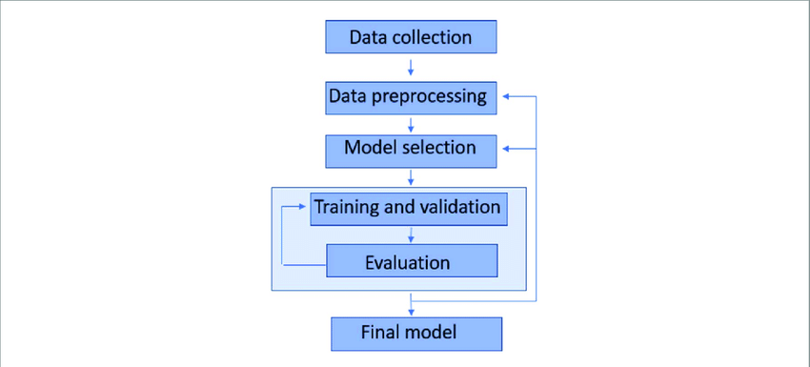

Table-1 : Components & Technologies:

|  |  |  |  |
| --- | --- | --- | --- |
| **S.No** | **Component** | **Description** | **Technology** |
| 1. | Data Collection | Gathering relevant data sources | Gathering relevant data sources |
| 2. | Deriving new features | Cleaning and transforming data | Web frameworks (Flask, Django) |
| 3. | Deriving new features | |  | | --- | | Deriving new features Cleaning and transforming data | | Web frameworks (Flask, Django) |
| 4. | Deriving new features | Cleaning and transforming data | Web frameworks (Flask, Django) |
| 5. | Deriving new features | Deriving new features | Web frameworks (Flask, Django) |
| 6. | Deriving new features | Deriving new features | Web frameworks (Flask, Django) |
| 7. | Deriving new features | Deriving new features | Web frameworks (Flask, Django) |

Table-2: Application Characteristics:

|  |  |  |  |
| --- | --- | --- | --- |
| **S.No** | **Characteristics** | **Description** | **Technology** |
| 1. | User-friendly | User-friendly | User-friendly |
| 2. | User-friendly | User-friendly | User-friendly |
| 3. | User-friendly | User-friendly | User-friendly |

|  |  |  |  |
| --- | --- | --- | --- |
| **S.No** | **Characteristics** | **Description** | **Technology** |
| 4. | User-friendly | User-friendly | User-friendly |